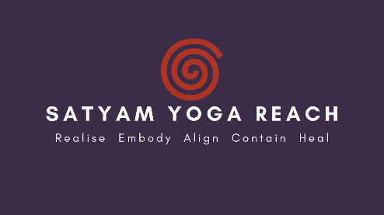

Satyam Yoga Teacher Training Programme 2024 - 2026 Application Form
Name: Pronouns:

Email address: Date of birth:

Phone number: Home address:

Current work/profession:

Experience of yoga and/ or meditation (e.g years, teachers, styles):

Other training qualifications/ previous studies:

Do you have a current sadhana (personal practice)?

Why would you like to take this course? (continue on a separate sheet if necessary)

Are you able to commit to a daily practice for the duration of the 2 year programme?

Are you able to commit to the 20 weekend sessions and 3-4 day residential retreat in Summer 2026?

Are you requesting a Support or Solidarity Space? If so, please give details below:

Any other comments:

Signed: Dated:

Thank you for your application. Please return the completed form to Chiraswa@satyamyogacentre.co.uk

