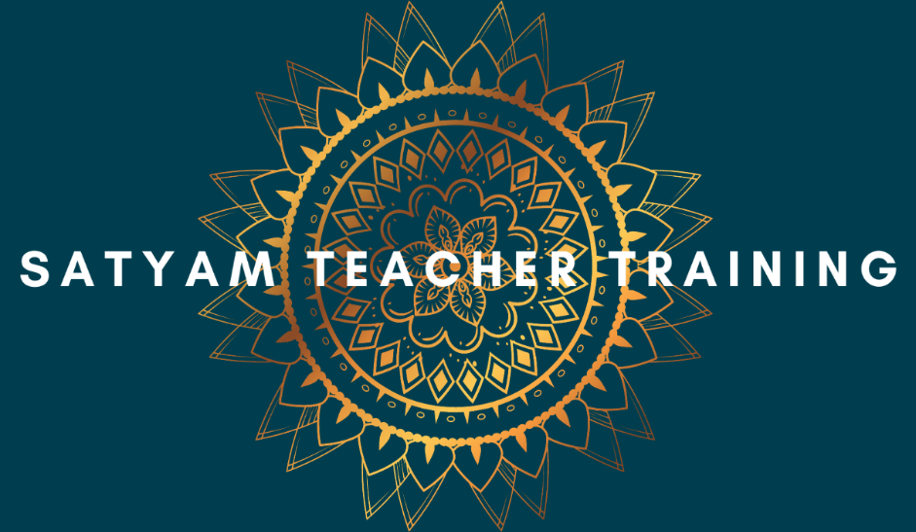
Satyam Yoga Teacher Training Programme: March 2023 - March 2025
Application Form

Name:
Email address:
Phone number:
Home address:
Date of birth:
Current work/profession:

Other training qualifications/ previous studies:

Experience of yoga and/ or meditation (e.g years, teachers, styles):

Why do you wish to do this course?

Thank you for your interest in this course. Please return the completed form to Jo@satyamyogacentre.co.uk

